Work report 13 august 2021

Today I have completed the trainng of yolo v4 on chair and person on 6000 epoch(which is recommended for 2 classes). I have used mossisc ,blur,mixup

Results are as follows :

1.6000 epochs

Train

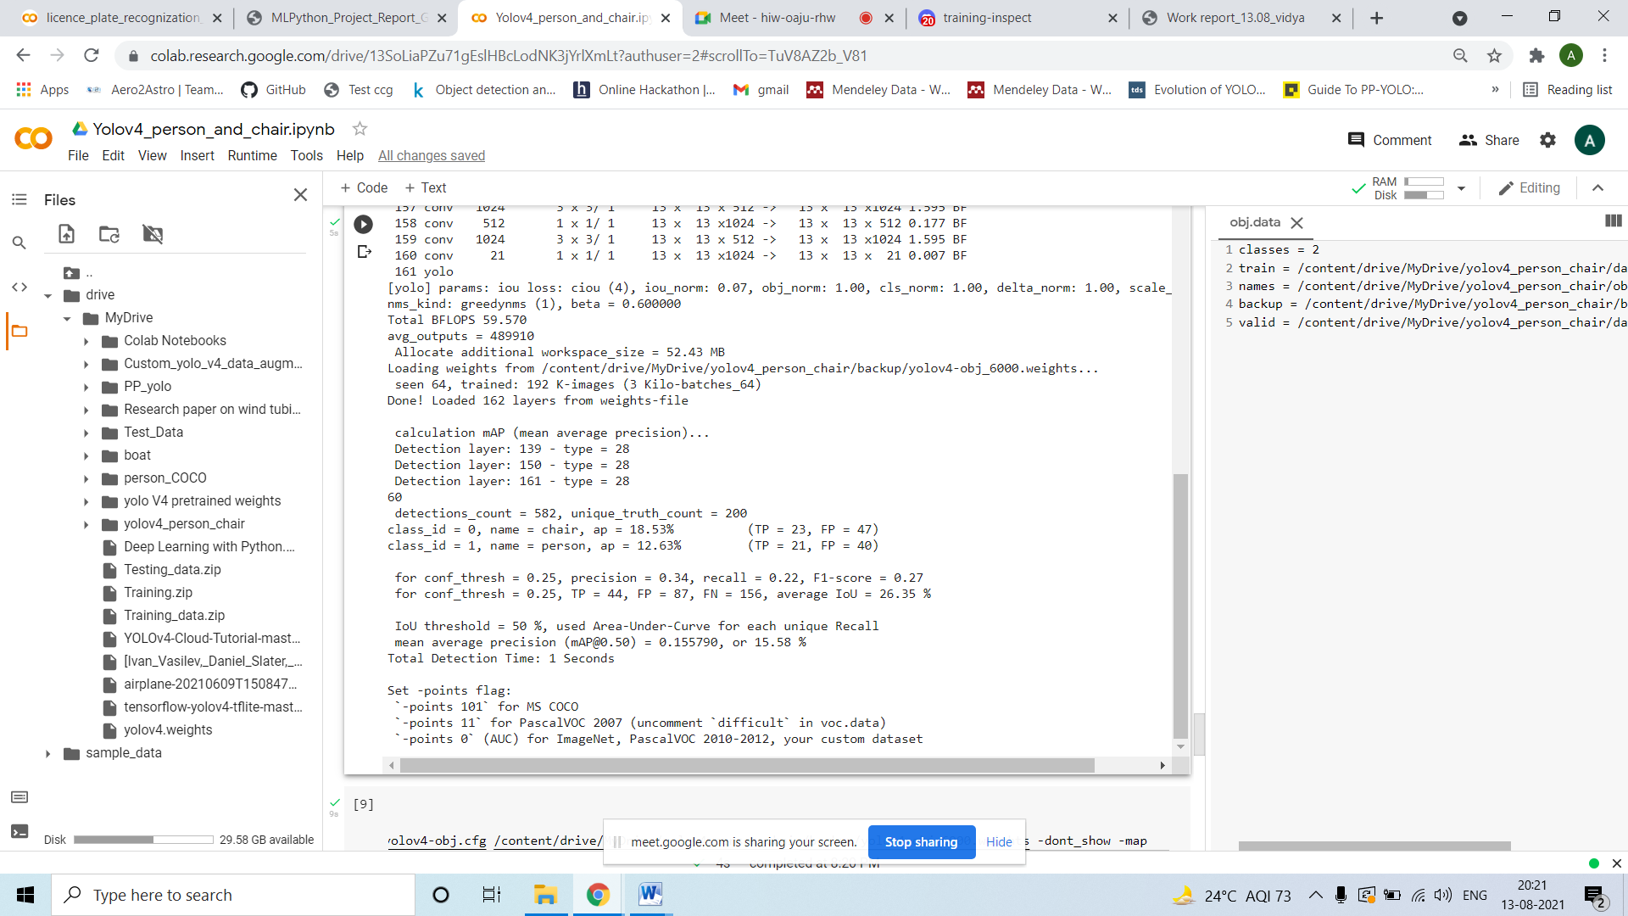

**Test**

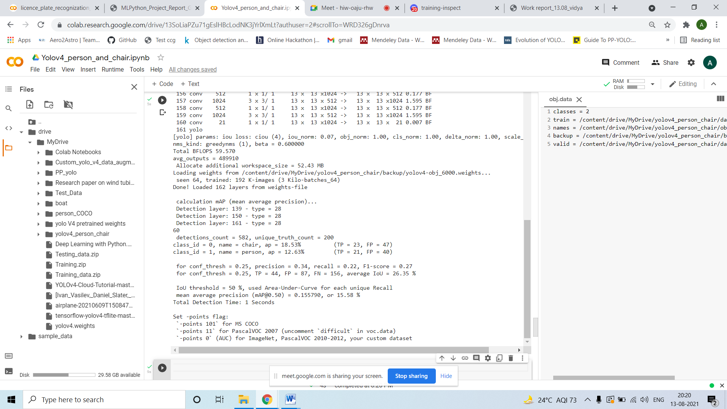

**The Map on test data keep decresing on incresre in epochs. I have saved weights per 1000 epochs. The map on on train data keep increasing as epochs increses.**